# **Name: Abdurrahman Qureshi**

# **Roll No: 210451**

Practical No: 12

1. **Loading a Progress bar**

**CODE:**

Public Class Form1

Private Sub Form1_Load(sender As Object, e As EventArgs) Handles MyBase.Load

Me.Text = "EXP12ProgressBar"

Me.BackColor = Color.FromArgb(29, 29, 29)

startStopBtn.Font = New Font("Comic Sans MS", 12.0) loadingPercentage.Font = New Font("Comic Sans MS", 8.0) loadingPercentage.ForeColor = Color.AntiqueWhite

loadingStatus.Font = New Font("Comic Sans MS", 15.0) loadingStatus.ForeColor = Color.AntiqueWhite

End Sub

Private Sub startStopBtn_Click(sender As Object, e As EventArgs) Handles startStopBtn.Click

If startStopBtn.Text = "Start" Then

loadingStatus.Text = "Loading..."

startStopBtn.Text = "Stop"

Timer1.Start()

ElseIf startStopBtn.Text = "Stop" Then

loadingStatus.Text = "Press Start to continue"

startStopBtn.Text = "Start"

Timer1.Stop()

End If

End Sub

Private Sub Timer1_Tick(sender As Object, e As EventArgs) Handles Timer1.Tick

Dim i As Integer

If progressBar.Value < progressBar.Maximum Then

progressBar.Value += 1

i = progressBar.Value

loadingPercentage.Text = i & "%"

Else

Timer1.Stop()

End If

End Sub End Class

**OUTPUT:**

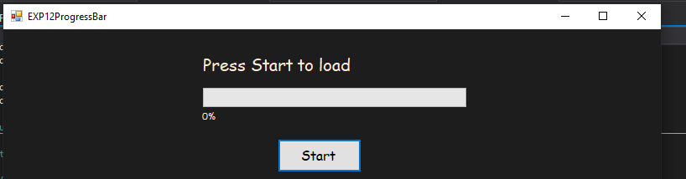

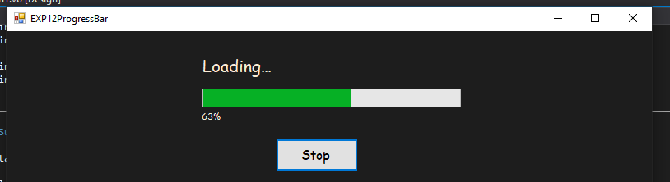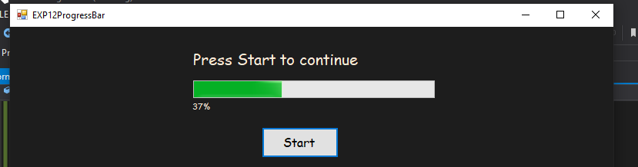

1. **Generatin’ a Traffic Signal**

**CODE:**

Private Sub Timer1_Tick(sender As Object, e As EventArgs) Handles Timer1.Tick

Static count As Integer = 0 ' create a static variable to keep track of time

count += 1 ' increment the count variable by 1 each time the Timer ticks

Select Case count ' check the value of the count variable

Case 1 To 3 ' first 10 seconds, show green light

OvalShape1.FillColor = Color.Red

OvalShape2.FillColor = Color.Gray

OvalShape3.FillColor = Color.Gray

Case 4 To 7 ' next 5 seconds, show yellow light

OvalShape1.FillColor = Color.Gray

OvalShape2.FillColor = Color.Orange

OvalShape3.FillColor = Color.Gray

Case 8 To 10 ' next 10 seconds, show red light

OvalShape1.FillColor = Color.Gray

OvalShape2.FillColor = Color.Gray

OvalShape3.FillColor = Color.Green

Case Else ' after 25 seconds, reset the count variable and start again

count = 0

End Select

End Sub

End Class

**OUTPUT:**

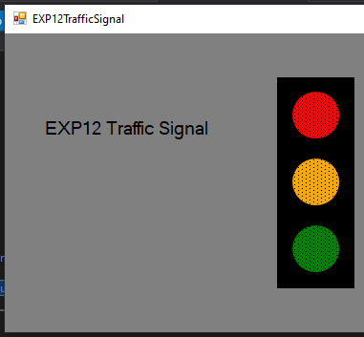 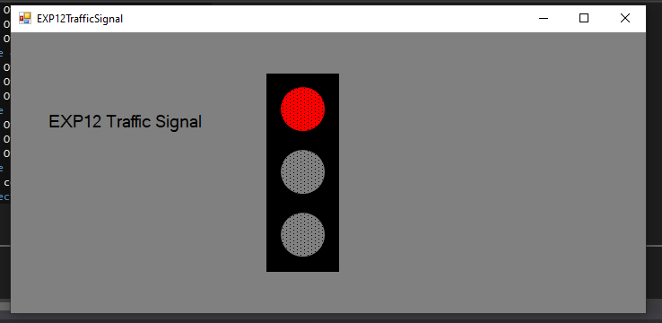 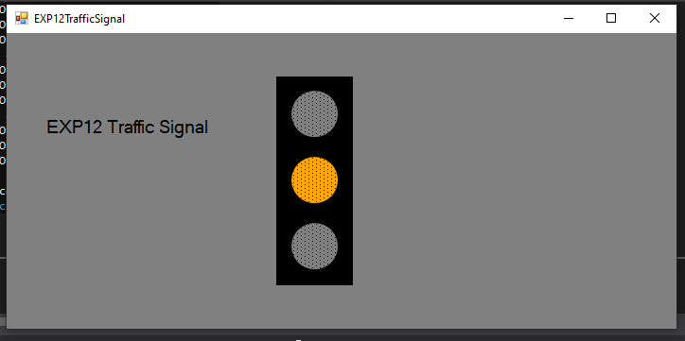 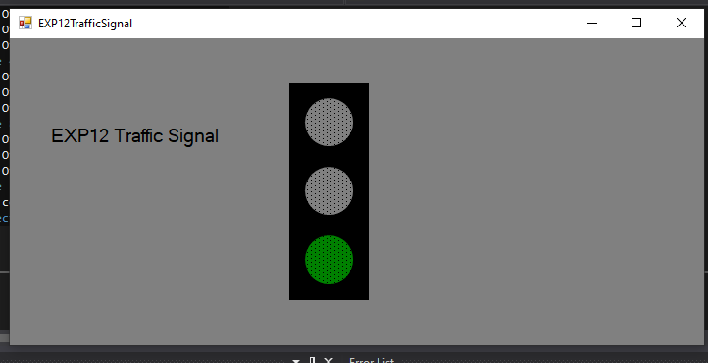

1. **Creatin’ and usin’ TabControls – Theme change also**

**CODE:**

Public Class

Form1

Private Sub Form1_Load(sender As Object, e As EventArgs) Handles MyBase.Load

Me.Text = "EXP12TabControl"

Me.BackColor = Color.GhostWhite

TabPage1.BackColor = Color.GhostWhite

TabPage2.BackColor = Color.GhostWhite

End Sub

Private Sub FactBtn_Click(sender As Object, e As EventArgs) Handles FactBtn.Click

Dim n As Integer = FactInput.Text

Dim resultFact As Integer = 1

For i As Integer = 1 To n

resultFact *= i

Next

ansFact.Text = resultFact

End Sub

Private Sub FiboBtn_Click(sender As Object, e As EventArgs) Handles FiboBtn.Click

Dim n As Integer = fiboInput.Text

Dim c As Integer

For i As Integer = 0 To n

c += i

Next

ansFibo.Text = c

End Sub

Private Sub Button1_Click(sender As Object, e As EventArgs) Handles Button1.Click

If Button1.Image.Equals(My.Resources.LM1) Then

Button1.Image = My.Resources.DM1

TabPage1.BackColor = Color.FromArgb(29, 29, 29)

Label1.ForeColor = Color.GhostWhite

Label2.ForeColor = Color.GhostWhite

Button1.ForeColor = Color.FromArgb(29, 29, 29)

Button2.ForeColor = Color.FromArgb(29, 29, 29)

Else

Button1.Image = My.Resources.LM1

TabPage1.BackColor = Color.GhostWhite

Label1.ForeColor = Color.FromArgb(29, 29, 29)

Label2.ForeColor = Color.FromArgb(29, 29, 29)

Button1.ForeColor = Color.GhostWhite

Button2.ForeColor = Color.GhostWhite

End If

End Sub

Private Sub Button2_Click(sender As Object, e As EventArgs) Handles Button2.Click

If Button2.Image.Equals(My.Resources.LM1) Then

Button2.Image = My.Resources.DM1

TabPage2.BackColor = Color.FromArgb(29, 29, 29)

Label3.ForeColor = Color.GhostWhite

Label4.ForeColor = Color.GhostWhite

Button1.ForeColor = Color.FromArgb(29, 29, 29)

Button2.ForeColor = Color.FromArgb(29, 29, 29)

Else

Button2.Image = My.Resources.LM1

TabPage2.BackColor = Color.GhostWhite

Label3.ForeColor = Color.FromArgb(29, 29, 29)

Label4.ForeColor = Color.FromArgb(29, 29, 29)

Button1.ForeColor = Color.GhostWhite

Button2.ForeColor = Color.GhostWhite

End If

End Sub

End Class

**OUTPUT:**

